**IMPAC-T organized 2011 Chaophraya river flood Seminar**

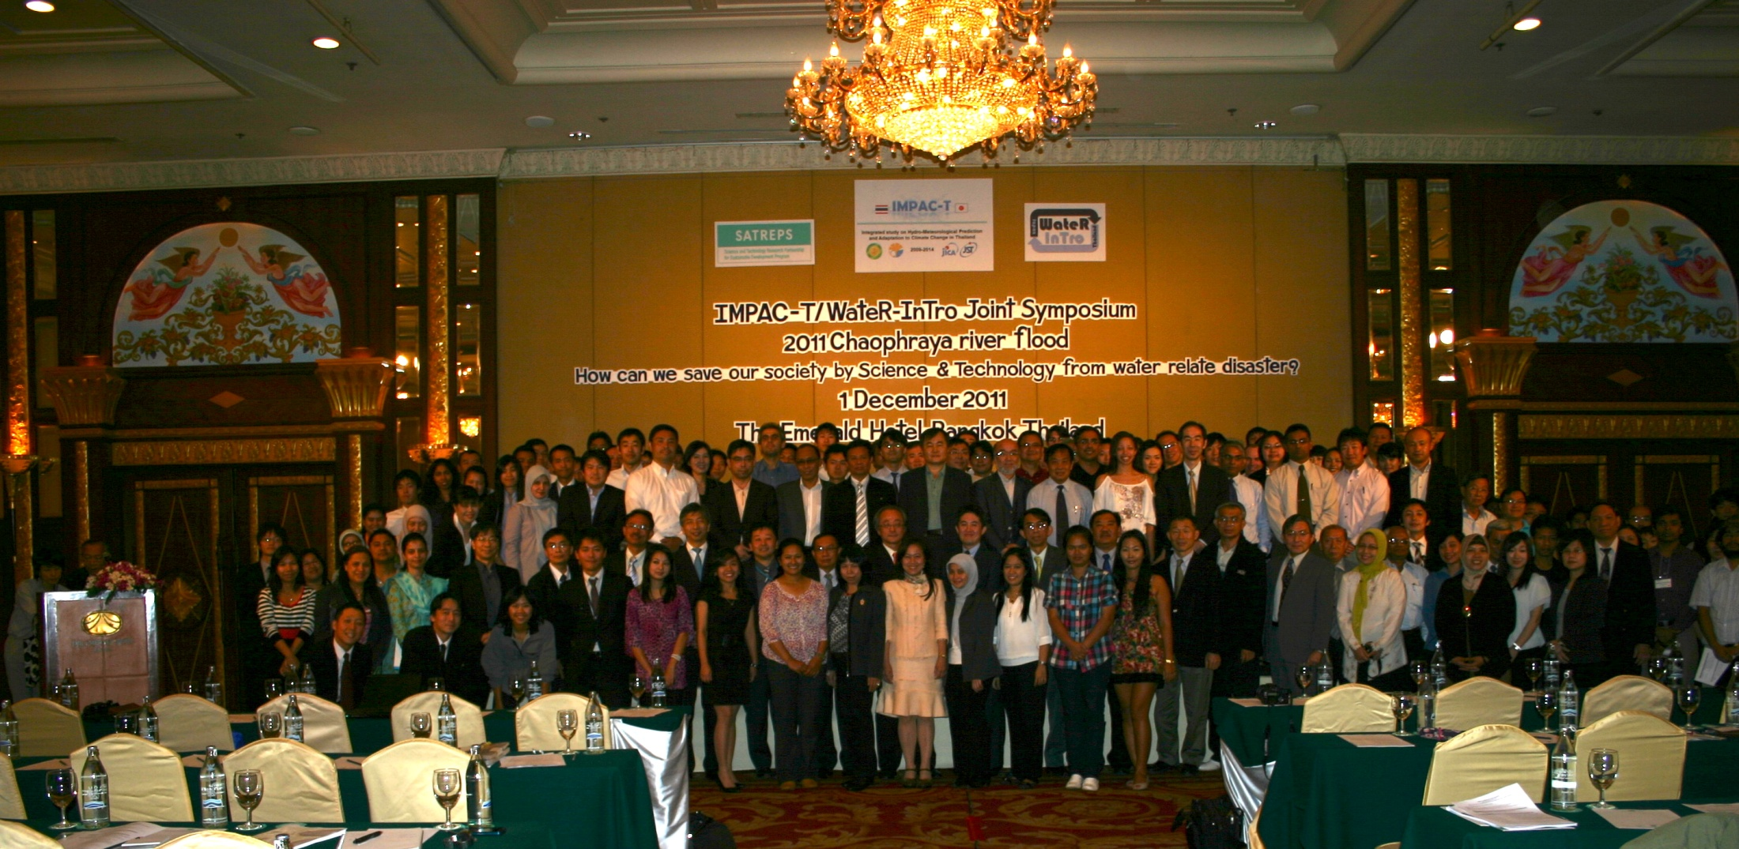

According to the big flood in Chaophraya river during September – October 2011, the seminar on “How can we save our society by science & technology from water relate disaster “ was jointly organised by IMPAC-T and WateR-Intro and was supported by SATREP, Japan . The seminar was held on 1 December 2011 at The Emerald Hotel , Bangkok. The seminar was attended by a total of nearly 200 participants from various government and non-governmental organizations including the deputy prime minister, Kittirat Na Ranong.   
A total of six presentations were made during the seminar. The presentations focused on causes of flood , methodology and findings of the study as well as on the problems encountered during the flood period . The discussion following the presentations included flood disaster mitigation, development of coping mechanism, implementation of structural and non-structural measures for flood disaster mitigation and institutional set-ups in the watershed. It was strongly recommended by the participants that the IMPAC-T project should be continued for solving the future flood.